IC SYSTEMS INC (TORT)
&
BROADCOM INC
FINRA might be involved.

I need you to help spread this to others because These companies are ILLEGALY PROSECUTING ERIK IVAN RIVERA (ME) OVER FALSE ALLEGATION AND PUTTING ERIK (ME) TO DEATH OR TO SLEEP FOREVER BY INDUCING COMA, BRAIN INERTIA USING MS.

G.N.H is being used as the reason to put ERIK RIVERA TO DEATH. G. gave Erik the instruction during a visit at Harris County Sherrifs Office Sherriffs Office Jail in 2017 while he was waiting his court setting with attorney Adam Banks Brown court room 228 with Judge Joe Carter Brown. (my favorite Judge).
During the visitation window he told Erik, “I want you to repeat after me, ‘gives erik a trade-secret belonging to his private company/ linked to His network Team/ so Erik Does exactly as instructed and conveys to Adam at following court date.
Erik did Not know that he was already being eavesdropped on or tapped by Alfred Galindo or Jason Carl Pennington.
Erik just remembers that Alfred and Jason mentioned the trade-secret to Erik Rivera, which gave a hint that they knew about Erik.
This has been reason for Jason to deploy SEAL team to station at
Erik’s company HQ who have been ever vigilant since then, but it seems like an error or typo in a command chain script or a “string” in the source code and linked to integrated API and other AT&T/ T-Mobile IBM

4:42 Houston Community College (Alief) 9/5/2023 active on computer my W21574346, ERIK IVAN RIVERA. Active Parallel Project build, IP/ What is Mirror augment to perception API/ What is hemisphere?

Are these collaborators getting away with murder, manslaughter, or attempting to “rip” an integrated cerebral cortex to achieve Erik to pass away/ or brain death, just like Mark Daniel Nemic and his sister revealed to Erik During his living at 3007 Larknolls Lane Houston Texas, while owner of house worked on his “project” using “corona” to cover up his “family hit plan” and other code words that gave hint to Mr. Rivera that showed proof that a “dirty cop/ impersonator of badge” is/was at work, like “crocodile” -when he said “they are going to put him with the crocodiles” as EFF.org is showing on their site. Electronic Frontier Foundation, who partners up with Police Departments, and also works to protect and enforce law cybersecurity.

https://www.eff.org/pages/crocodile-hunter
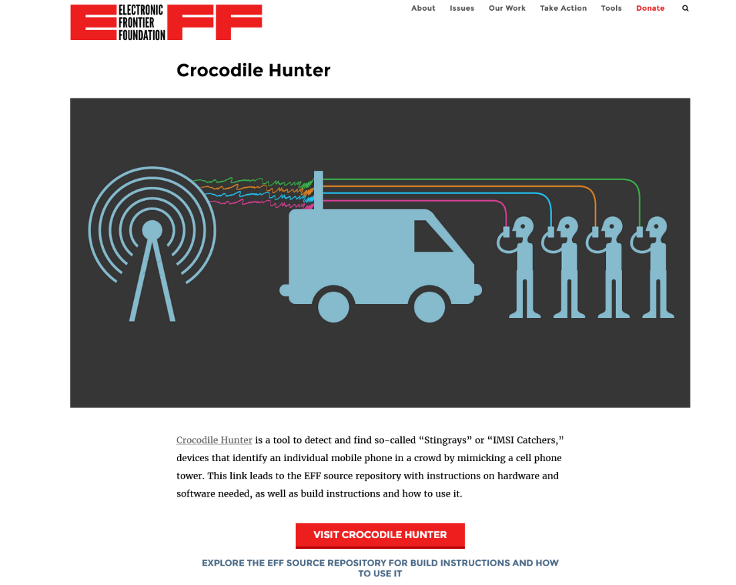

Have been overlooking several complain on file by Erik Ivan Rivera, in order to keep up the discrimination that pursues evident fraud & forgery.
Installed components, assistive technologies and monitoring settings contribute to testicular pains, IoT ballon device in rectum as explosive threat and to stop anal sex,
He has been destroying all of my relationships with other men, It has been evident that ESTEBAN TAMAYO from TAMAYO TAX and INSURANCE on ALLEN GENOA in Pasadena, Texas 77502, has been intruding United States and stealing SSN from citizens and impersonating them.

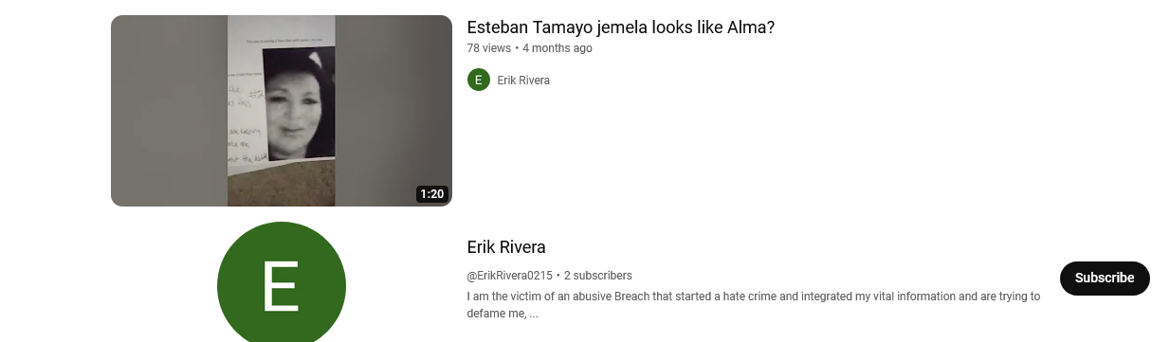
[https://youtu.be/OdrN2Crq4-o?si=2tW1vTtkDEt3bC8J]

This discloses a Group of individuals who engage in foreign practices and trafficking after extracting IP data from client (me) and using mirror codes that enable bypass of law and also reflects IP user data/ API holder.
One of the documents that Mr. Rivera caught and managed to keep on his files, after his failed first attempt of copy/paste, making sure that the second one did not disappear from storage, was found under the label “cerebro_min.js”
This gives factual evidence supporting possible integrated subject linking to personal Health Information/ electronic health records (eHR) neural network/ stroke and other medical practices.

I request that we stop this immediately. The company was contracted fraudulently by Thomas Smith, who took over an account at T-Mobile 346-290-3095, originally created without my consent by maybe Jason Carl Pennington, Ex partner/ friend, who paid for the bonding company around February 2018.
A-Mobile Bail Bonds is owned by Larry Smith, who also post his business on Zoominfo.com and Linkedin and advertises Third Party for T-Mobile’s ((RF)) Management and Network Strategy.

Subject: Please go over these in your p

This message might be followed by one or multiple attempts of intercepting or neutralizing my subject.

This is how you know that the details are worth knowing. Some of the subjects that it involves are: Child sexual abuse, manslaughter, wronged victim pursuing civil-death, Federal Violations some which involve (militia), A bonding agency, that has history in the News section on how one of their "Bounty Hunters kills their Black Clients (white supremacist)" and they get away| The bond has contract that discloses Federal Credit Union records and statement of API use, But does NOT give the agency permission for experimental rights with client's IP, nor incorporating of partnerships || Bounty Hunters engage in discrimination against client SPN023399218 for be bisexual and recording selfies of himself using his cellphone engaging in X activity.
Now, the details of the TAP, Trace/ track/ pen-register/ Roving reached Mr. Dexter's APIs who has incorporated his Mass Broadcasting disclosing the client and how his mother Alma Diana Dozal De Hoyos is abused over her son, Erik, and forced to watch him engage in same-sex with other men, while she is harassed, or "tortured" (according to internal dialogue).
Other collaborators and project developers T-Mobile third-party carriers cognitive/mobility have been overlooking Erik’s attempt to request investigation due to the malicious activity causing him headaches, migranes, muscle spasms, pains, unnecessary brain stimulation and more debts.

AT&T/ IBM;
* IC SYSTEMS as a debt collector for T-Mobile Inc -account take-over by ||Thomas SMITH suspicion related to Larry SMITH owner of A-Mobile Bail Bond||
IC SYSTEMS

while engaging in fraudulent allegations.

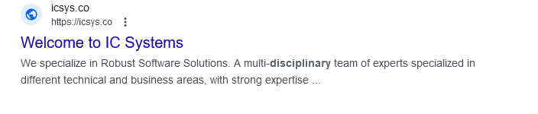

[https://www.intrinsix.com/ic-development-multi-disciplined-team-deployment]



What is a cryptologist hacker (tortious) military AI platform deployment, unreported project development using application programming interfaces (API) to integrate services using my Internet Protocol address (IP)?
Who do I reach out to if there is active source code data reflection, exposing Federal space matters (foreign intelligence, translated transversals involving quantum spatial ), thus, placing my life and health under jeopardy of punishment or death due to the use of my social security number to engage in tradeops with foreign jurisdiction and governments?
How do I securely convey this to the correct council or agency? I have noted physical evidence of what is suspected as fraudulent badge impersonating federal agent, or ICE Immigration?
Who do I contact, so that I am enrolled in appropriate training, so that my IP (Hybrid) may continue to sustain a bilateral supplement to current business intelligence workforce life-force, without exposing and minimizing vulnerabilities?
IF you can assist me in reaching out to NASA, or other Geospatial Intelligence agencies so that I can reach mutual contract for constituting a government requesting Green House Gas (GHG) radar to cover radius around my IP under (private arrangement) since we will be working with advanced programming which may/does augment to maintaining essential core principles in demand for sustainable energies and supply chains. I need package tracing and to discover intercept or spoofing, (IP2IP).
There is a request that we discover medical device/ nodes/ conductors/ harnessed by my IP or using my PI/ PII/eHR.
Can you please connect me with a federal funding program, so that I can be covered for in need of housing, medical, food, training or military schools (algorithm warfare ops/ ELINT) Companies in use of my IP, PII:
T-Mobile USA Inc.
[https://acrobat.adobe.com/id/urn:aaid:sc:VA6C2:b0603659-3001-4765-9881-eeb2798b9e6c]
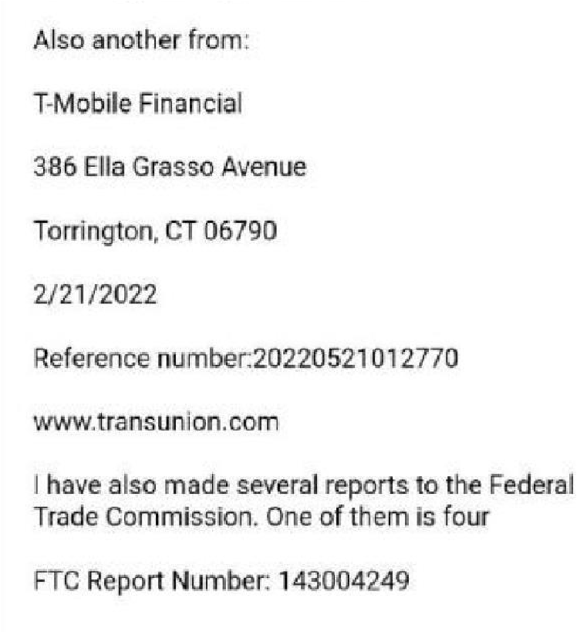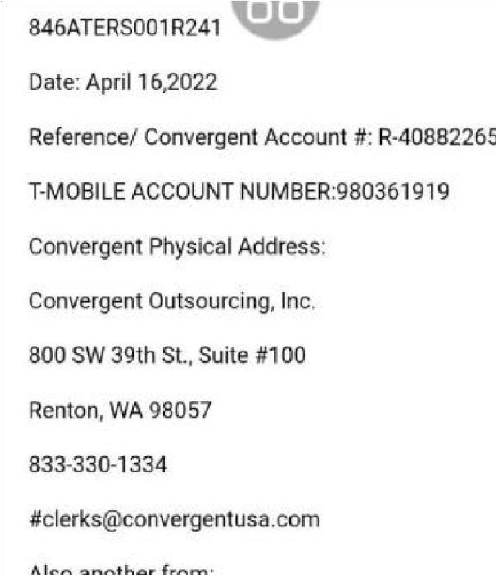
Zoominfo.com for
[https://www.zoominfo.com/p/Larry-Smith/3433246069]
[https://www.zoominfo.com/p/Larry-Smith/3433246069]
The owner of A-Mobile Bail Bonds, Larry Smith runs a third party business for T-Mobile RF management and network strategy (third party)
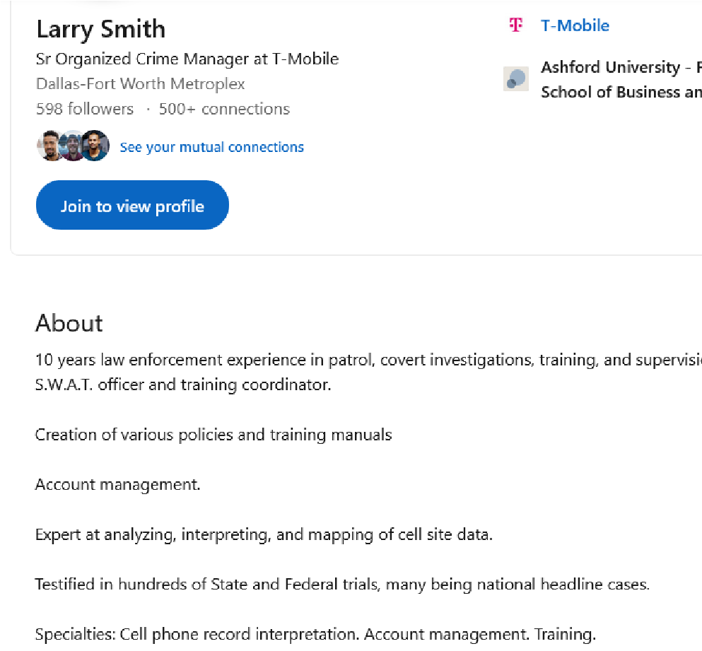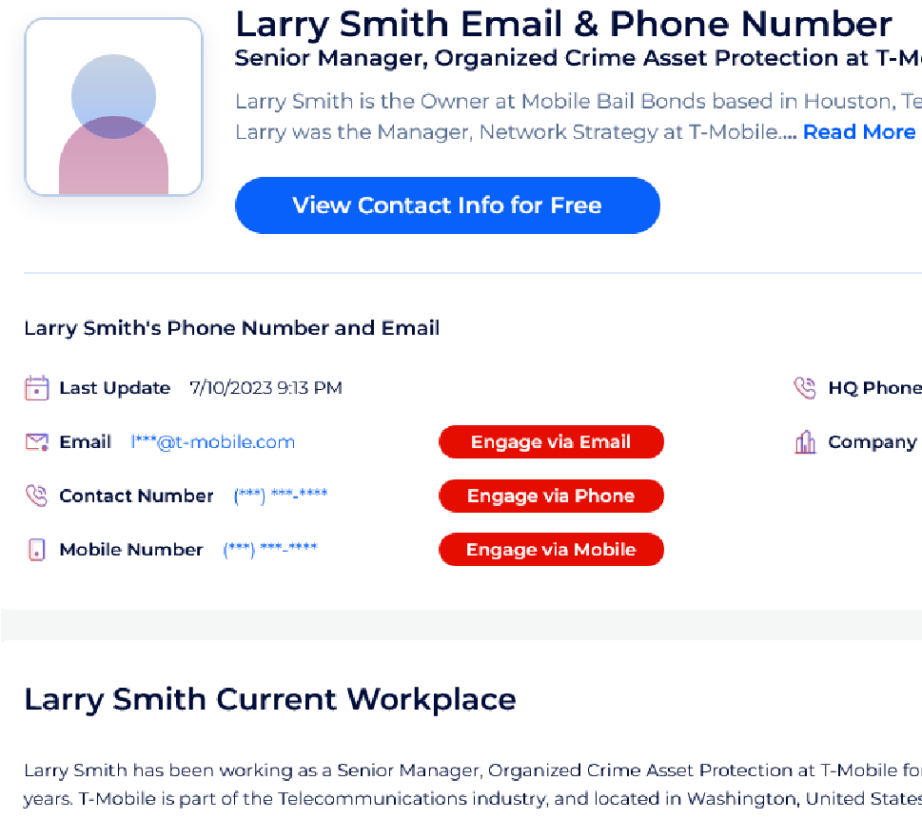
I am former client under SPN:02399218, The bond was paid for by Ex partner/ friend Jason Carl
Pennington, Military Veteran, Navy SEAL
The co-signers Alfred Galindo (long time friend), and Alma Diana Dozal De Hoyos (mother) were given a document to sign to release Federal Credit Union records. In this document There is a print that states that the company works with third party programs and Application Programming Interfaces (API). I do believe that personal details here were breached.
A T-Mobile representative told me that the system shows that someone started something (program), but never finished it. Did not release records to me because it would violate privacy. It is using my social security number, I need to know details.
T-Mobile proceeded to tell me that a person named Thomas Smith took over my phone number 3462903095, claimed ownership this includes bills and debts just an FYI
Possible Telecommunications Company:
https://www.zoominfo.com/c/nastykinkpigs/450773381
A person (incognito) disclosed details that involved an ongoing recording which involves monitoring.
I do believe that I am entitled to compensation, due to Intellectual Property Copyright violations, stealing or extracting personal information, for business practices.
I do not request that the network be cut off, or that the backbone link terminating current supplementary/ sustainable business health data and transport to corresponding domain/ IP assigned to me trains me to manage and access the command chain /script for security reasons.
Broadcom Inc:
[https://www.youtube.com/@erikirivera5409]
These are videos that I managed to catch while a deployed monitoring device became active and evidently tracing me. This is shown in the video by showing you the WI-FI device name, and then showing you the GPS maps, that way you can see that it is not just on one geographical area. Also followed in train station at one point.
The Broadcom Inc has been invading my personal space and monitoring me without my consent and surely integrated with other details that involve the disclosure of my health records and other unauthorized electronic transmissions. Note, that my intent is/was not to prosecute the company or individual doing this, but more like a warning to not use my information without my consent. It is essential that I know the details of his company’s objective and that I see the what the blueprint is to his project, so that I can know what are the licenses that I need to obtain, so that I can carry and mange the build.
What is Unnecessary API Machine behavioral programming leading to neurological impairments?
[https://acrobat.adobe.com/id/urn:aaid:sc:VA6C2:ad0ec0d1-508a-40f0-aa3b-e3d60131d11d]
A second Time I discovered a source code program eavesdropping on my Browser’s developer settings under the name of: “cerebro_min.js”
The first time the guy on the same time at a hotel on his laptop sat down and then the program appeared. I managed to copy and save the file, but the file was lost by the morning.
A health symptom that I have been experiencing after I stand up is head rushes, vision blackout, tingling in body (sign of blood flow returning to head) or sometimes after I do a 180 degree turn, which is a sign that a Cell Site Location Information (CSLI) program activates a reaction in the command chain after it recognizes my Global Position direction. It also plays with other projects that involve Geo fencing of select areas usually for securing confidentiality, privacy or avoiding interference. Maybe like a pin being used by a stakeholder.
I searched up the term “cerebro_min.JS” and it shows ties that connect to neural networks, which in turn link to other medical treatments and programs for stroke, vertigo, epilepsy, heart key vital information.
The Symptoms I show are progressions to stroke.
(accessible?)
What I conclude is that a breach uses my information to create tracker/tracer/ pen-register (TAP) with carrier providers, such as T-Mobile and AT&T, thus, enabling watcher to retrieve data for filing applications, authorizing grants and power of attorney.
IP is retrieved to deploy AI/ Machine platform and node info. to begin developing unmutual projects that integrate API, allow SQL injections, and PHP collaborate. More than probable linking to the suspected Broadcom Inc. we see on YouTube.

This part may be for a Private detective
Unusual changes began at my mom’s apartment on Charles ST #18 in Pasadena Texas 77506 that began showing my little brother’s Braulio’s computer desktop language to Spanish from English. This also involves the OS, to other organizational/ enterprise settings.
This is around the time that my mother began having visits by her “boyfriend” Esteban, who supplied State-Farm insurance to the black car she bought me. This is also the time frame I discovered a box in her kitchen filled with fraud bank statements from Wells Fargo, and the death benefit for $ 30,000 using my name and Diana as the policy holder.
The Life/ Death Policy tie in to the current project in development with IP is using mirrored application to bypass or penetrate cybersecurity systems and jurisdictions // (un)parallel networks?)
This is one of the goals that I believe Esteban Tamayo (mother’s “husband”) and his associates are focuses on. They prepared ahead of time, organized/ orchestrated since the year of late 2017- early 2018.
He wants money after Esteban and associates contribute to me dying from natural causes.
The details are found within the Houston Police Department and surrounding precincts, also other federal departments and Child protective services. It will fill in the remaining gaps with extravagant detail.

--------------------------------------------------------------------------------------------------------------------

A person hacked into my HHS EHR records and filed applications for 1 power of attorney, 2 monitoring devices, medical devices, GPS trace, thinking assessments (MHRM), History analytics.
This is not authorized by me, but it is very clear that several individuals have been exposed to the credentials installed during his unexpected project build on my IP and is now currently being programmed with interfaces and other technologies settings (integrated API), Which are not acceptable to to me, or I lack the training to manage.
This concludes of a greater than a four year setting that has been interfering with social security information, credit scores, Technologies//telecommunications RFC bindings, in addition to IC SYSTEMS INC, and granting a BROADCOM INC. permissions to have interface and monitoring activity accessing vital health information.
Some symptoms are causing what I see sufficient to simulate a progression of "stroke, vertigo, dopamine block, excitability control, loss of enthusiasm, and other IC systems that may require clearance for management.
A mining company that is not reported may have taken place and still active, There is a transport business not presenting license or warrants for the inspection/ searching of private territories prior to construction, or enabling transit for exporting business practices.

Evident that professional ethics retrieved from the mind of a business-associate are not applied. Discrimination or racial comments that insult sex, expose events during in-home by casting or reflecting the idea subject to outdoor organizations or during outdoor activity and cause comments against hate that show either disgust in crowds, frustrations.
It shows a disturbance to the people that I come around.
I see reactions that has them yelling but it always relates to the activity that I was engaged in during indoor privacy.
This has me under current neglect, source code experimenting with Application programming interface API IBM which is also enough reason of logic that the perpetrator has gained entry and access to [https://www.irs.gov/irm/part2/irm_02-005-003]

There are projections that distract or divert attention by placing focus on irrelevant factors to exclude my comprehension and sense from Real Time factors that derive from components, which may be a sign that the abuser has reached access to sensitive information, such as the Internal Revenue Service (IRS) that lack the supervision of profession and ethic. It involves great amounts of discrimination, ongoing threats, no board for monitoring deployed services which may also include private codes (militia).

Please subpoena records from AT&T's Telephone & Department of Public Records (DPR) in demand that T-Mobile presents activity records that use my social security number so that we know what agencies or departments to contract with. This was we may safely, securely, restore subject IP to original settings or jurisdictional grounds.

Subpoena Council On Recovery on Jackson Hill to present document under the tittle of "EL BORRADOR".
Subpoena ESTEBAN TAMAYO at 2208 LILLIAN STREET, PASADENA TEXAS 77502 to
present his warrants or license
suspected behaviors from mother Alma Diana Dozal De Hoyos who is under a false investigation or hold by impersonators of ICE immigration badge// or federal agents from collaborators of a stalking hate crime also cyber abuse and tele-services.
One under "forced marriage" and blamed on me.

This has caused permanent physical damage to nervous system from an amputation on hand, that involves an attempted murder which I was able to evade from the attack of three individuals with hatchet, pipe and other tools. Finger was chopped off by the hatchet. Several reports, still no investigations, HPD, AG, Courts, TDFPS, CPS, +

respond as soon as possible:

ERIK IVAN RIVERA
SSN 645-24-9504
DOB:021519

^^^
RE:
We received your question or complaint for erik Rivera. If we don't contact you within 3 work days, call us at 1-877-787-8999 (toll-free). You will need to give us the tracking number below. If you gave us your e-mail address, we will send this message to: rebelstar@duck.com
Tracking Number: A08312023.0130025

NOTES:
From the IRS:
“The development of software utility programs, such as debuggers, backup systems, performance analyzers, data recovery, etc.
Utility software applications generally utilize software interfaces, or application programming interfaces (APIs) that already exist in the system. Typical activities may involve understanding the capabilities of the underlying system, including the existing APIs, devices, file systems, and/or databases, that may be needed as part of the business component. For example, to develop a business component to backup data on a computer generally involves an understanding of the file system on the computer (i.e., how to find the location of a file on a hard disk, and how to retrieve the entire file, etc.), the devices to which the backup files will be written (e.g., hard disk, tape, floppy disk, CD, etc.), and the underlying application programming interfaces provided by the operating system (e.g., Microsoft Windows, IBM's MVS, UNIX, etc.). Such software development does not generally involve activities which are directed at resolving software development uncertainties through identifying and conducting a process designed to evaluate alternatives which fundamentally relies on the principles of computer science.

Alternatively, for example, a software utility program designed to recover data from a hard disk, even though the file was previously deleted and its disk space reused by other applications, may involve design uncertainties which can only be resolved through identifying and conducting a process designed to evaluate alternatives, which fundamentally relies on the principles of computer science”

Reverse engineering.
Reverse engineering activities typically consist of examining existing programs, databases, and files in order to figure out how an existing
application really works. For example, if a new application was supposed to interface with an existing legacy application, then the software engineers might need to reverse engineer the data interface supported by the legacy application. Reverse engineering is not qualified research under I.R.C. § 41(d). See Treas. Reg. § 1.41-4(c)(10), Example 8.

May require the use of such websites : [phpMyAdmin
phpMyAdmin

]

1. The mission of IT eDiscovery is to:
- Institutionalize and execute IRS’s repeatable process for Electronic Discovery (E-Discovery)
- Assure IRS responsiveness to litigation requiring E-Discovery for civil cases, as well as Freedom of Information Act (FOIA) requests (administrative phase)
- Raise awareness across IRS and partner with all business functions to educate the workforce about E-Discovery
- Integrate the E-Discovery process and technology (new and existing) with applicable business and IT enterprise processes
1.1.12.5.3(08-01-2018)

